NAME:SaadMunir

REGNO:8160

Assignment no. 1

Due Date: 24th February, 2025

1️ E-Commerce App (Online Shopping)

Design an E-Commerce app in Figma that includes a visually appealing product list, product details, and cart screen. How will you ensure a smooth user experience for browsing products and checking out?

Expected Figma Design Deliverables:

- Home Screen: Grid/list of products, categories, search bar.

- Product Details Screen: Images, description, add to cart.

- Cart Screen: Selected items, price details, checkout button.

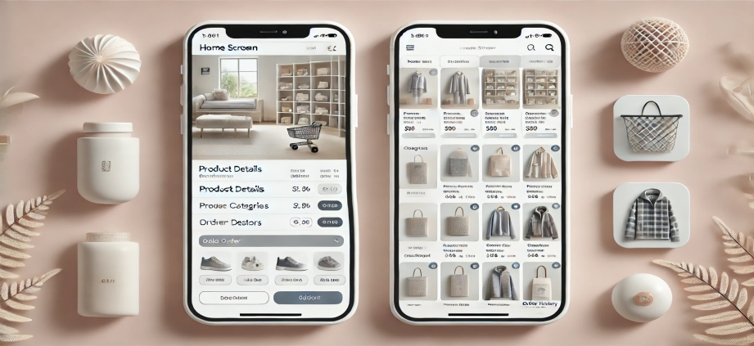

2️ Social Media App

Design a social media app UI in Figma that includes a login/signup screen, feed, and profile page. How will you create an engaging layout for posts and user interactions (likes, comments, shares)?

Expected Figma Design Deliverables:

- Login/Signup Screen: Simple and clean authentication UI.

- Feed Screen: Post layout, images, video previews, like/comment buttons.

- Profile Screen: User info, bio, followers count, posts grid.

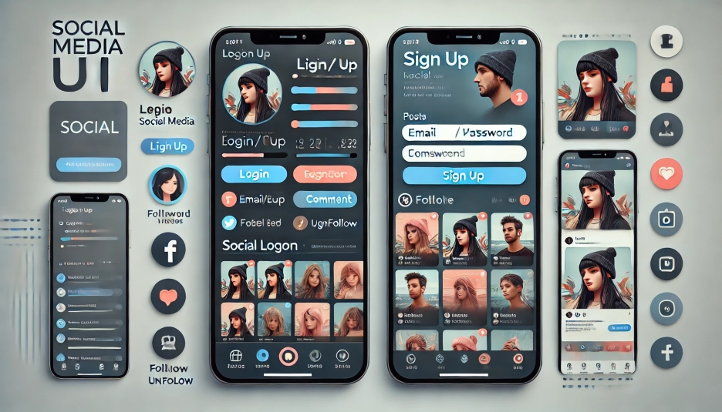

3️ Ticket Booking App (Movies, Events, Travel)

Create a Figma design for a ticket booking app, ensuring users can easily search for events and complete the booking process. How will you organize the UI for seat selection and ticket confirmation?

Expected Figma Design Deliverables:

- Home Screen: List of available events, movies, or flights.

- Booking Details Screen: Select seats, showtime, pricing.

- Payment Screen: Payment options, order summary.

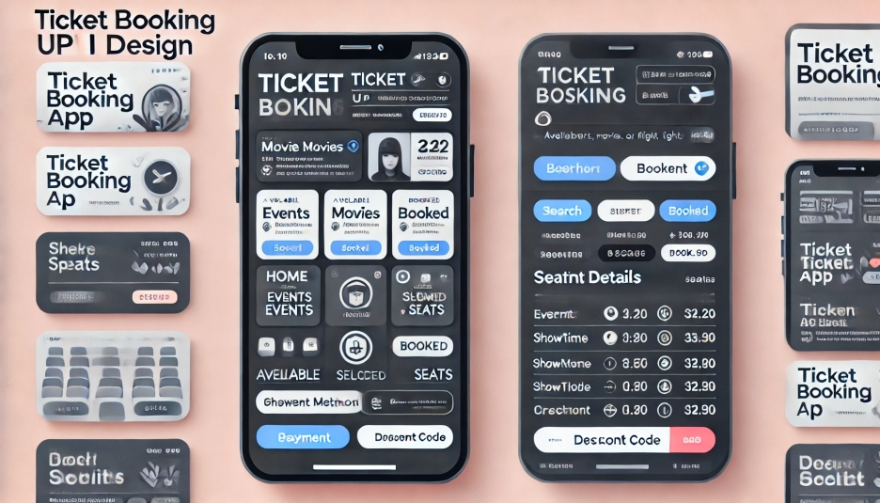

4️ Expense Tracker App

Design an Expense Tracker UI in Figma that helps users efficiently track income and expenses. How will you visually represent financial insights and analytics?

Expected Figma Design Deliverables:

- Dashboard Screen: Overview of expenses, income, and balance.

- Add Expense Screen: Input for amount, category, date.

- Reports & Analytics Screen: Graphs, charts, and spending trends. 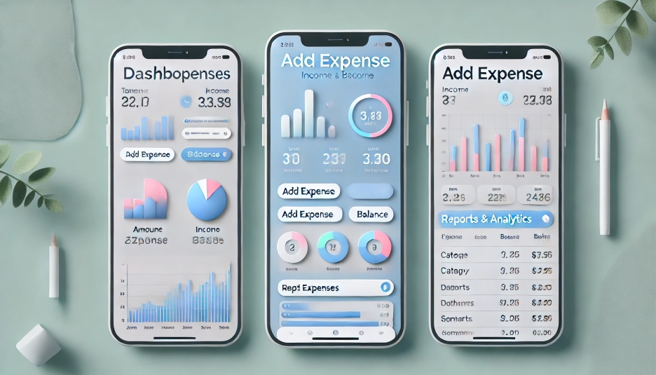

5️ Food Delivery App

Design a modern Food Delivery app UI in Figma that makes it easy for users to browse restaurants, place orders, and track deliveries. How will you make the menu visually engaging?

Expected Figma Design Deliverables:

- Home Screen: List of restaurants, featured dishes, search bar.

- Restaurant Details Screen: Menu, reviews, add to cart button.

- Order Tracking Screen: Live status of order delivery.

